Project Design Phase-II

Data Flow Diagram & User Stories

|  |  |
| --- | --- |
| **Date** | **16 October 2022** |
| **Team ID** | **PNT2022TMID26521** |
| **Project Name** | **IOT based smart crop protection system for agriculture** |
| **Maximum Marks** | **4 Marks** |

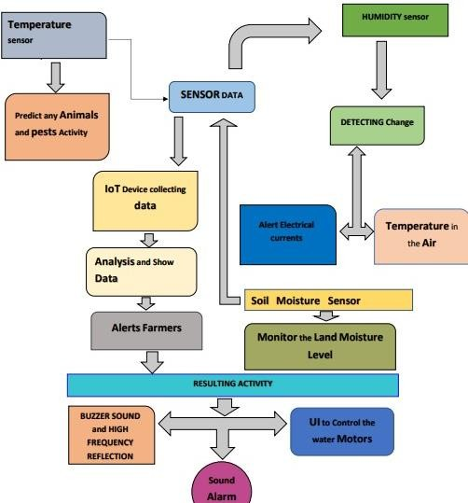Data Flow Diagram:

**User stories:**

|  |  |  |  |  |  |  |
| --- | --- | --- | --- | --- | --- | --- |
| **User Type** | **Functional requirement (Epic)** | **User Story numbe**  **r** | **User Story/Task** | **Acceptance criteria** | **Priority** | **Release** |
| **Mobile users** | Registration | USN-1 | User can enter into the web application | I can access my account  /dashboard | High | Sprint 1 |
| USN-2 | User can register their credentials like email id and password | I can receive confirmation email & click  confirm | High | Sprint 1 |
| Login | USN-3 | User can log into the application by entering email & password | I can login to my account | High | Sprint 1 |
| Dashboard | USN-4 | User can view the temperature | I can view the data given by the device | High | Sprint 2 |
| USN-5 | User can view the level of sensor monitoring value | I can view the data given by the device | High | Sprint 2 |
| **Web users** | Usage | USN-1 | User can view the web page and get the information | I can view the data given by the device | High | Sprint 3 |
| **Customer** | Working | USN-1 | User act according to the alert given by the device | I can get the data work  according to  it | High | Sprint 3 |
| USN-2 | User turns ON the water motors/Buzzer/Sound Alarm when occur the disturbance on field. | I can get the data work  according to it |  | Sprint 4 |

|  |  |  |  |  |  |  |
| --- | --- | --- | --- | --- | --- | --- |
| **Customer care Executive** | Action | USN-1 | User solve the problem when some faces any usage issues | I can solve the issues  when some one fails to understanding the procedure | High | Sprint 4 |
| **Administration** | Administration | USN-1 | User store every information | I can store the gained  information | High | Sprint 4 |